Integrating the Healthcare Enterprise



IHE PCC

Technical Framework Supplement

OB Labor/Delivery and Postpartum Record
(OB-LDP)

Public Comment

Date: January 02, 2009
Author: Ana Estelrich
Email: ana_estelrich@yahoo.ca or ana.estelrich@sante.gouv

This is a supplement to the IHE PCC Technical Framework V4.0.

It is submitted for Public Comment between <June 15, 2008 and July 15, 2008>.
Comments shall be submitted within that period to http://forums.rsna.org:
- Select the “IHE” forum
- Select PCC Technical Framework
- Select 2009-2010 Supplements for Public Comment
- Select OB-LPD
Please use the Public Comment Template provided there when starting your New Thread.

Details about IHE may be found at: www.ihe.net

Details about the IHE PCC may be found at: http://www.ihe.net/pcc/committees/index.cfm

Details about the structure of IHE Technical Frameworks and Supplements may be found at: http://www.ihe.net/About/process.cfm and http://www.ihe.net/profiles/index.cfm

The current version of the IHE PCC Technical Framework may be found at:. http://www.ihe.net/Technical_Framework/index.cfm

These ”boxed” instructions are for the author to indicate to the Volume Editor how to integrate the relevant section(s) into the overall Technical Framework
Replace Section X.X by the following:
TABLE OF CONTENTS
Introduction Error! Bookmark not defined.
Profile Abstract 2
Open Issues and Questions 2
Closed Issues 2
Volume 1 – Integration Profiles 2
Glossary 2
1.7 History of Annual Changes 2
2.1 Dependencies among Integration Profiles 2
2.2.X <Profile Name> Integration Profile 2
X <Profile Name> Integration Profile 2
X.1 Actors/ Transactions 2
X.2 <Profile Name> Integration Profile Options 2
X.3 <Profile Name> Process Flow 2
X.4 <Profile Name> Security Considerations 2
<Appendix A> Actor Summary Definitions 2
<Appendix B> Transaction Summary Definitions 2
Volume 2 - Transactions 2
3.Y <Transaction Name> 2
3.Y.1 Scope 2
3.Y.2 Use Case Roles 2
3.Y.3 Referenced Standard 2
3.Y.4 Interaction Diagram 2
<Appendix letter> Appendix_Name 2

Introduction
After a patient delivers, the labor and delivery record is typically used by the postpartum and nursery/NICU units to get an overview of the labor and delivery course of the mother and delivery information regarding the newborn. This information is very useful in the postpartum care since the attending obstetrician may or may not have been present at the birth. The labor and delivery record would offer the provider the pertinent delivery information, such as complications that may need to be reassessed or require follow-up. Furthermore, in the in-patient setting for the newborn, the pediatrician would also refer to the labor and delivery record for details, such as chorioamnionitis in labor or trauma from birth, which might be pertinent for the infant’s plan of care. Continuing the mother and newborn care, a postpartum record is produced following the care administered during this period. This information is equally important as it provides a comprehensive view of the status of the mother and the new born at the time of delivery.

In some settings, public health officials are interested in the labor/delivery and postpartum information as to better monitor the mother and child’s health and intervene if necessary.

Certain data present in the labor/delivery and postpartum record is monitored anonymously as to conduct studies about the health population. The public health aspect is out of scope of this profile and it is addressed in the Mother and Child profile in the Quality, Research and Public Health domain.

Profile Abstract
The labor and delivery summary is important for care of the mother and newborn in both the inpatient and outpatient settings after delivery. Information that can affect the care of the mother and/or the newborn should be available to all care providers.. Also, the obstetric postpartum discharge summary communicates information necessary for continuing patient care of the mother and/or the newborn after delivery. The patient(s) receives a comprehensive assessment which provides the follow-up care provider with a “snap-shot” of the patient's condition at discharge.

The general administered health care workflow resulting in the collection of the information is as follows:

- Information is recorded about the labor
- A labor record is produced
- Patient delivers in the hospital (most likely) or other setting
- A delivery summary is produced
- Care/examination is provided to the new born in the postpartum setting (most likely the hospital).
- A postpartum record is produced
- The information about the mother and child, since standardized, can be shared seamlessly between the stakeholders

The information collected varies according to the type of birthing facilities, their birthing practices and location, and also depends on the characteristics of mothers and newborns. Personnel and Health care practitioners using the information contained in the OB Labor/Delivery and Postpartum Record could be: attending physicians, resident physicians, and staff (during postpartum care in the hospital), obstetrician-gynecologists, family physicians, pediatricians, social workers, covering physicians, other medical specialists, researchers, patient safety and quality offiicers, and public health officials. The information needs to be uniform in terms of structure and content so that the document can be shared between all the stakeholders. Also, this information may also be incorporated into a patient's PHR. In some countries the OB Labor/Delivery Record is to be kept for 20 years, and it is collected by child care services, as well as public health officials for epidemiological studies.

National extensions can be produced if the regional needs are slightly different; nevertheless, the main information of the record is most likely universally the same, facilitating interoperability.

Open Issues and Questions
< List of open issues/ questions that need to be addressed prior to publishing of the Technical Framework>

Closed Issues
< List of closed issues/ questions with their resolutions that have been addressed prior to publishing of the Technical Framework>

Volume 1 – Integration Profiles

Glossary
Add the following terms to the Glossary:
<any glossary additions associated with the profile draft go here> - to be done yet

1.7 History of Annual Changes
<Brief overview of “what’s new” in the given year of the Technical Framework.>
Add the following bullet to the end of the bullet list in section 1.7
- Added the OB-Labor/Delivery and Postpartum Record Profile which provides the means to capture standardized information about the labor, delivery and postpartum care administered to the mother and the newborn. This information can be shared between the health care professionals and the interested parties such as social workers or public health officials.

2.1 Dependencies among Integration Profiles
Add the following to Table 2-1

OB-LPD | <?> | <?> | <->

Add the following section to section 2.2

2.2.X OB Labor/Delivery and Postpartum Record Integration Profile
The information collected during the labor and delivery as well as during the postpartum period is very important for the follow-up care that they receive both in an outpatient setting or when the patient is transferred to a higher level of care (either high risk maternal or neonatal transport). As in the inpatient setting, the obstetrician and pediatrician need to have the pertinent information from the delivery in order to properly plan the follow-up care for the mother or newborn. For example, a mother might need a follow-up hematocrit testing or evaluation of the incision site in the office, and this information might be noted on the delivery summary. Other important information can be: delivery type, labor type and anesthesia type, postpartum complications and specific maternal information such as medications, labs, allergies and plans for contraception.Specific neonatal information, might include name, gender, birth weight, apgar scores, medications received including immunizations, etc. All this information can be obtained in the OB Labor/Delivery and Postpartum Record.

Add Section X

X OB Labor/Delivery and Postpartum Record Integration Profile
<Introductory Description/ overview of Integration Profile. May be the same as 2.2.X if that’s all it takes.>

The information collected during the labor and delivery as well as during the postpartum period is very important for the follow-up care that they receive both in an outpatient setting or when the patient is transferred to a higher level of care (either high risk maternal or neonatal transport). As in the inpatient setting, the obstetrician and pediatrician need to have the pertinent information from the delivery in order to properly plan the follow-up care for the mother or newborn. For example, a mother might need a follow-up hematocrit testing or evaluation of the incision site in the office, and this information might be noted on the delivery summary. Other important information can be: delivery type, labor type and anesthesia type, postpartum complications and specific maternal information such as medications, labs, allergies and plans for contraception.Specific neonatal information, might include name, gender, birth weight, apgar scores, medications received including immunizations, etc. All this information can be obtained in the OB Labor/Delivery and Postpartum Record.

X.1 Actors/ Transactions
<Actor/ Transaction diagram and Actor/ Transaction table. >
Figure X.1-1 shows the actors directly involved in the <Profile Name> Integration Profile and the relevant transactions between them. Other actors that may be indirectly involved due to their participation in <other related profiles>, etc. are not necessarily shown.

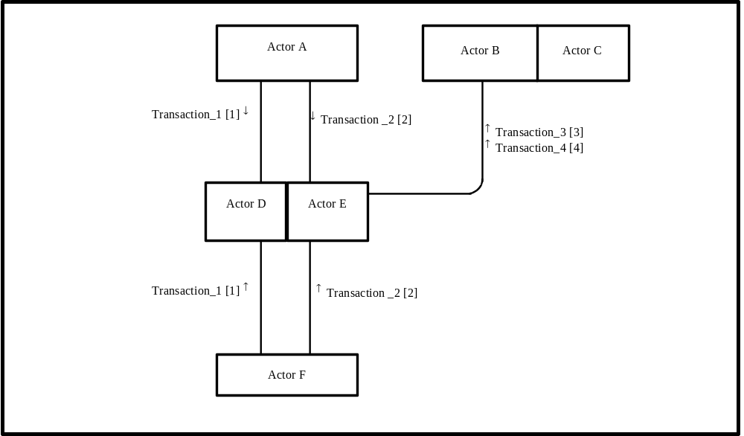
Figure X.1-1. <Profile Name> Actor Diagram
Table X.1-1 lists the transactions for each actor directly involved in the <Profile Name> Profile. In order to claim support of this Integration Profile, an implementation must perform the required transactions (labeled “R”). Transactions labeled “O” are optional. A complete list of options defined by this Integration Profile and that implementations may choose to support is listed in Volume I, Section X.2.

Table X.1-1. <Profile Name> Integration Profile - Actors and Transactions
Actors | Transactions | Optionality | Section in Vol. 2
Actor A | Transaction_1 | R | Z.1
Actor A | Transaction_2 | R | Z.2
Actor F | Transaction_1 | R | Z.1
Actor F | Transaction_2 | R | Z.2
Actor D/ Actor E | Transaction_1 | R | Z.1
Actor D/ Actor E | Transaction_2 | R | Z.2
Actor D/ Actor E | Transaction_3 | R | Z.3
Actor D/ Actor E | Transaction_4 | R | Z.4
Actor B (Actor C) | Transaction_3 | R | Z.3
Actor B (Actor C) | Transaction_4 | R | Z.4
Note: This is a note

X.2 OB Labor/Delivery and Postpartum Record Integration Profile Options
<Table describing the options available for this integration profile and references to all sections that state requirements for compliance to the Option.>
Options that may be selected for this Integration Profile are listed in the table X.2-1 along with the Actors to which they apply. Dependencies between options when applicable are specified in notes.
Table X.2-1 <Profile Name> - Actors and Options
Actor | Options | Vol & Section
Actor A | No options defined | - -
Actor F | No options defined | - -
Actor D/ Actor E | No options defined | - -
Actor D/ Actor E | No options defined | - -
Actor B (Actor C) | No options defined | - -
Actor B (Actor C) | No options defined | - -

X.3 <Profile Name> Process Flow
<Description of the process flow(s) and sequence diagram(s) covered by this profile in order to satisfy the use cases. This often will include a brief description of the use cases as well. If there are detailed behavioral rules that apply to a specific process flow or multiple process flows or descriptions then an appendix may be added as needed>

Case 1
A 30 year-old pregnant woman (41 weeks gestation), mother of six, starts having contractions. She chooses to stay home, in a familiar environment. Seven hours later she feels that her contractions have become much closer and her water has broken. Her partner calls for medical assistance. She is admitted to the labor and delivery unit labor. Her cervix is 3 cm dilated. She refuses to have her labor augmented and refuses placement of an IV or any other medical interventions. 10 hours later she is still in labor, and her myometrial contractions are deemed to be inadequate, she is now febrile, and there is little change in her cervical dilitation. Particulate meconium is now observed. The fetal monitor strip is indicating fetal decelerations to 60 with contractions and loss of variability. It is deemed that the baby’s well-being is jeopardized. She has an emergency conversation with the mother who succeeds in convincing the patient to undergo an emergency C-section procedure. The baby is finally delivered and shows signs of cyanosis. He is passed to the pediatrician. A laryngoscope aspiration is performed and then oxygen therapy (PEEP - Positive end-expiratory pressure) is administered for the next 5 minutes. APGAR scores are 3 at 1 minute and 6 at 5 minutes.

There is no seizure activity noted however due to the weak initial APGAR scores and the suspicion of hypoxia, sepsis, and potential for meconium aspiration, the baby is admitted to the NICU for further stabilization and monitoring. A critical care transport to a tertiary level NICU is being considered for this infant.

The attending physician notes all the information in the labor and delivery record. She deems that the mother is at risk for a postpartum hemorrhage and endomyometritis considering that she is a multiparus and had chorioamnionitis prior to the C-section. Her shift being over, she discussed her findings with her replacement, who will also find the detailed information in the labor and delivery record.

The information is also transferred to the mother and newborn’s PHR, respectively.

Due to meconium aspiration syndrom it is recommended that the infant is transported to another hospital, with a quaternary level NICU for potential ECMO therapy. The information is accessed by the Medical Control Officer prior to the transport so that appropriate action can be taken if need arises. The receiving facility checks the infant’s record and is well informed of his condition.

The appropriate treatment for the management of postpartum hemorrhage and endomyometritiis prevention is commenced.

Due to the information captured in the labor and delivery record, as well as the information in the pregnancy record (summary), mother and baby were given proper treatment.

Case 2
Inpatient care for the mother is completed, and she is discharged. A postpartum discharge Record is created and shared with the patient’s primary health care provider (PCP). The infant remains hospitalized at the quaternary level NICU in a city 50 miles away.
The mother decides to stay with her parents, who live in the city near the hospital where her infant is receiving care. Shortly after, she develops high fever, chills, shivering, flushing, and sweating. Her mother calls her daughter’s obstetrician's office with questions. The delivery obstetrician is out of town. The local healthcare provider is unfamiliar with the patient's delivery. He checks the patient’s PHR and is able to provide appropriate care based on the assessments and interventions documented during the inpatient stay for the delivery and the postpartum discharge record. The mother is rushed to the hospital and antibiotics are given as to prevent a possible case of septicemia. This information is also captured in the patients’ PHR.
I think we should work on the baby’s course after discharge. This may not lead to childhood asthma but may require surveillance for other respiratory conditions or risk for illnesses such as RSV. The post-partum information becomes part of the child’s PHR, as to monitor for possible childhood asthma complications.

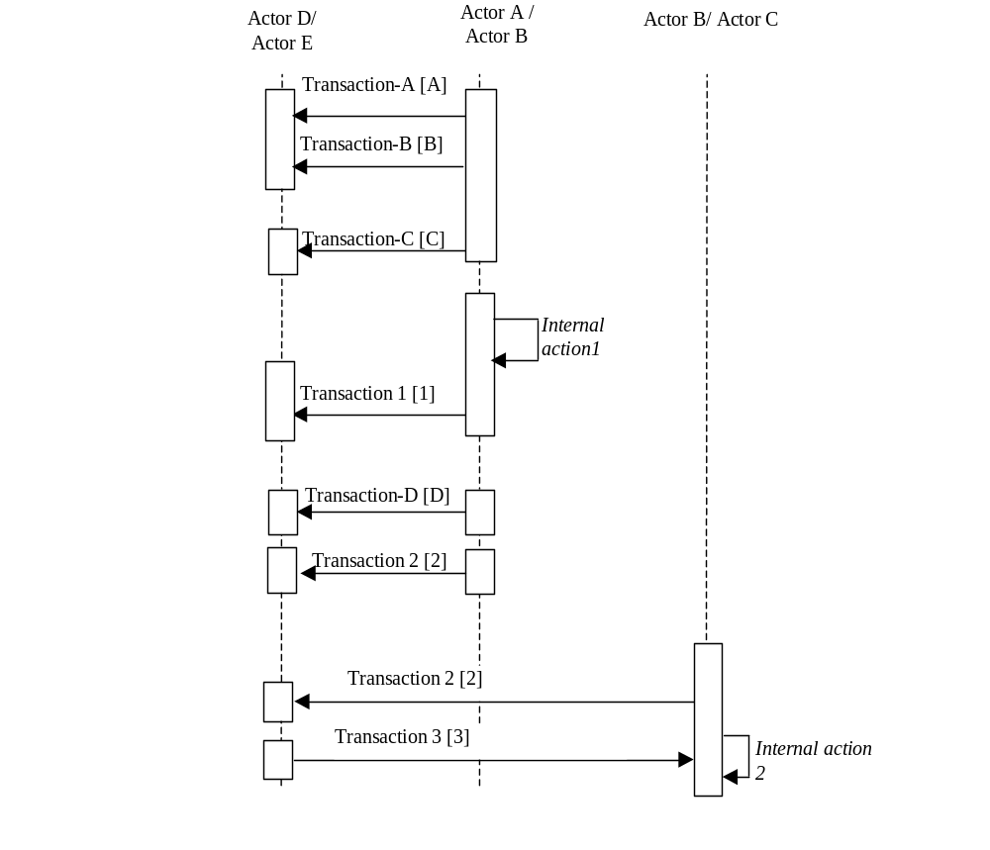
Figure X.2-1. Basic Process Flow in <Profile Name> Profile

X.4 <Profile Name> Security Considerations
<Description of the Profile specific security considerations. This should include the outcomes of a risk assessment. This likely will include profile groupings, and residual risks that need to be assigned to the product design, system administration, or policy.>
<Appendix A> Actor Summary Definitions
<add any actor definitions for new actors defined specifically for this profile>
<Appendix B> Transaction Summary Definitions
<add any transaction definitions for new transactions defined specifically for this profile>

Volume 2 - Transactions
Add section 3.Y

3.Y <Transaction Name>
This section corresponds to Transaction Y of the IHE Technical Framework. Transaction Y is used by the <ABC> and <DEF> actors.

3.Y.1 Scope

3.Y.2 Use Case Roles
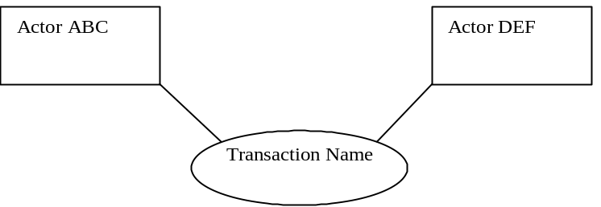

Actor:
Role:
Actor:
Role:
Actor:
Role: .

3.Y.3 Referenced Standard
<e.g., HL7 2.3.1 Chapters 2, 3>
<e.g. DICOM 2008 PS 3.3: A.35.8 X-Ray Radiation Dose SR IOD>

3.Y.4 Interaction Diagram
<the interaction diagram shows the detailed standards-based message exchange that makes up the IHE transaction>
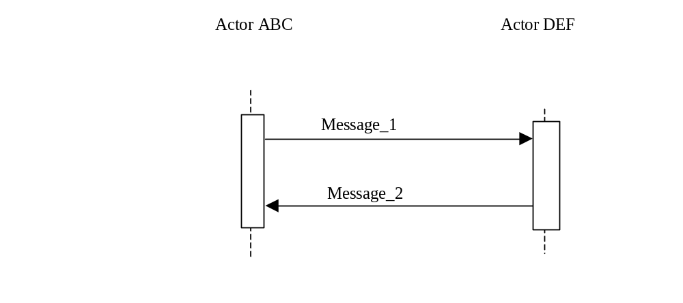

3.Y.4.1 <Message_1 Name>
<One or two sentence description of the first message of the above interaction diagram, typically relating the message to the relevant standard>

3.Y.4.1.1 Trigger Events
<description of the real world events that cause the initiation of the first message>

3.Y.4.1.2 Message Semantics
<detailed description of the meaning, structure and contents of the first message including any IHE specific clarifications of the message format, attributes, etc.>

3.Y.4.1.3 Expected Actions
<description of the actions expected to be taken as a result of sending or receiving this message>

3.Y.4.2 <Message_2 Name>
<One or two sentence description of the the next message in the above interaction diagram, typically relating the message to the relevant standard. Note, repeat this section as necessary based on the number of messages in the interaction diagram>

3.Y.4.2.1 Trigger Events
<description of the real world events that cause the initiation of the next message>

3.Y.4.2.2 Message Semantics
<detailed description of the meaning, structure and contents of the next message including any IHE specific clarifications of the message format, attributes, etc.>

3.Y.4.2.3 Expected Actions
<description of the actions expected to be taken as a result of sending or receiving this message>

3.Y.5 Security Considerations
<description of the transaction specific security consideration. Such as use of security profiles. >

3.Y.5.1 Security Audit Considerations
<This section should specifiy any specific ATNA security audit event that is associated with this transaction and requirements on the encoding of that audit event. >

3.Y.5.1.(z) Actor Specific Security Considerations
<This section should specifiy any specific security considerations on an Actor by Actor basis.>
<Appendix letter> Appendix_Name
<Detailed cross transaction relationships or mapping details are described in an appendix in Volume 2>

